**Detection of fecal coliforms in recreational waters and SARS-CoV-2 in sewage in the Ecuadorian Coast: a call for improving water quality regulation**

*Maritza Cárdenas-Calle1,2,3, Beatríz Pernia1,4 ,Leandro Patiño1,2,5, Roberto Erazo1,2, Carlos Muñoz3, Magaly Valencia-Avellán1,5, Mariana Lozada 6, Mary Regato-Arrata7, Miguel Barrera2,, Segundo Aquino3, Stalyn Moyano3, Stefania Fuentes3, Javier Duque1,2,3, Cecilia Uzca2 ,Luis Velazquez-Araque2,3,Hector Hugo2,, Bertha Carpio , Carlos Méndez, Carlos Calle,,1,11, Guillermo Cárdenas2, Miguel Uyaguari,12\**

1 Red Interinstitucional para el Estudio de Ecosistemas Acuáticos de Ecuador, Guayaquil, Guayas, Ecuador.

2Ambiente Sociedad & Empresa Researcher Group. Universidad de Guayaquil, Guayaquil, Guayas, Ecuador.

3 Faculty of Chemical Engineering, University of Guayaquil, Cdla. Universitaria “Universidad de Guayaquil”, Guayaquil 090510, Ecuador

4Faculty of Natural Sciences, University of Guayaquil, Cdla. Universitaria “Universidad de Guayaquil”, Guayaquil 090510, Ecuador

5 Dirección Técnica de Investigación, Desarrollo e Investigación, Instituto Nacional de Investigación en Salud Pública Dr. Leopoldo Izquieta Pérez, Guayaquil, Guayas, Ecuador.

6 Laboratorio de Microbiología Ambiental, Instituto de Biología de Organismos Marinos, CONICET, Argentina

7 Centro de Referencia Nacional de Virus Exantemáticos, Gastroentericos y transmitidos por vectores. Instituto Nacional de Investigación en Salud Pública Dr. Leopoldo Izquieta Pérez, Guayaquil, Guayas, Ecuador.

8School of Jurisprudence, Social Sciences and Politics, University of Guayaquil, Cdla. Universitaria “Universidad de Guayaquil”, Guayaquil 090510, Ecuador

9 Prefectura de Santa Elena.

10 Ministerio del Ambiente y Agua.

11 Universidad de Especialidades Espíritu Santo

12[Department of Microbiology](https://www.researchgate.net/institution/University_of_Manitoba/department/Department_of_Microbiology), University of Manitoba, Winnipeg, Manitoba, Canada

*Equal contribution

Corresponding Author:

Miguel Uyaguari12

Department of Microbiology

University of Manitoba

45 Chancellors Circle, Room 414D/Laboratory 118, Buller building

Winnipeg, MB Canada R3T 2N2

204-290-9548

[Miguel.Uyaguari@umanitoba.ca](mailto:Miguel.Uyaguari@umanitoba.ca)

**Abstract**

Wastewater surveillance represents an alternative approach for the diagnosis and early detection of infectious agents of public health importance. The objective of this work was to monitor fecal coliforms and SARS-CoV-2 and determine water quality in lagoon wastewater treatment systems of domestic origin in coastal areas of Salinas, Ayangue and General Villamil Playas in Ecuador. We conducted sample collection within two wastewater treatment systems and 15 coastal areas during two climatic seasons and tourist seasons in 2020 and 2021. Physico-chemical and microbiological parameters were evaluated to determine aquatic health and quantitative PCR (qPCR) was conducted for the detection of SARS-CoV-2. The SARS-CoV-2 virus was detected in the wastewater treatment systems in Playas and Santa Elena and two coastal zones. Results showed high levels of fecal coliforms, *Escherichia coli*, alterations in salinity level, dissolved oxygen concentrations, and chemical oxygen demand in areas close to fishing facilities, urbanizations, estuaries and bays mainly in the rainy season with open beaches for tourism activities.

**Introduction**

Recreational water includes rivers, lakes and coastal waters used generally for swimming, surfing, white water sports, diving, boating and fishing. They are usually found near urban areas and could be exposed to chemical and biological contaminants causing sanitary and ecological problems (Edokpayi et al., 2017). Fecal contamination and introduction of associated human pathogens (bacteria and viruses) is one of the main issues. It may occur through point source discharges (e.g. discharges of treated sewage/wastewater), runoff from urban or agricultural areas, bather and animal excreta (Bosh and Abad 2005). Targeted epidemiological studies in recreational water have found a cause–effect relationship between faecal pollution and enteric or acute febrile respiratory ~~(AFR)~~ illnesses, each of which accounts for more than 120 million and 50 million of cases respectively (Shuval, 2003). Surveillance data from the United States of America (USA) showed that, during 2009 and 2010, there were 24 recreational water disease outbreaks associated with the use of natural waters, 13 attributed to human pathogens. Microbial agents implicated included Campylobacter jejuni, E. coli O157:H7, *Shigella sonnei*, *Cryptosporidium* spp., *Giardia intestinalis*, *Avian schistosomes*, and *Norovirus* as the responsible of the largest outbreak [3].

Monitoring of recreational water for faecal contamination is a common policy in developed countries. It is done using some bacteria species as indicators (Gómez et al., 2008; Ramos Ortega et al., 2008), which include total and thermotolerant [faecal] coliforms, and enterococci. These bacteria are not postulated as the causative agents of illnesses in bathers, but appear to behave similarly to the actual faecally derived pathogens (Prüss, 1998). *E. coli*, in particular is one of the best indicators for gastroenteritis and dermal symptoms caused by seawater bathing (Cheung et al., 1999) (Vergaray et al., 1988, 1988), given its high frequency in domestic drains and longer survival time in seawater in comparison with other coliforms. It has similar survival time than some viruses such as human Rotavirus, an etiological agent of acute gastroenteritis in hospitalized children and one the most important causes of infant death (WHO, 2004).

The infectious agent “Severe acute respiratory syndrome coronavirus 2 (SARS-CoV-2)” causing COVID-19 is also excreted in faeces. Its main route of transmission occurs via respiratory droplets and human contact, and while environmental transmission has been suggested is still unclear. The virus nucleic acid has been detected in untreated and treated sewage in several countries including Australia, China, the USA, the Netherlands, France, Spain and Italy but also in rivers impacted by urban wastewater in Japan and Ecuador (Guerrero-La Torre et al. 2020, Haramoto 2020). Within this context, there are concerns that transmission from wastewater might occur or that viable viruses from its effluents reach water habitats posing a risk for the user or for the aquatic fauna. However, and based on indirect evidence, the risk of infection with SARS-CoV-2 from wastewater and recreational water bodies' is considered low (CDC 2020a, 2020b). In a recent publication, murine coronavirus hepatitis virus was spiked-in raw wastewater and showed a 90% reduction of infectivity after 13 h at 25°C but longer (36 h) at 10°C, the SARS-CoV-1 genetically closer to SARS-CoV-2 was found to be viable up to 14 days at 4°C and 2-3 days at ~20°C . While the risk of transmission of SARS-CoV-2 from water bodies needs further evidence, there are growing recommendations for its surveillance as an early warning tool for predicting outbreaks, occurrence, prevalence and potential public health risks in the communities (Masaaki et al.,2020).

In tropical countries such as Ecuador, beaches are visited by tourists from all over the country and abroad throughout the year. They are crowded especially on holidays, four of which (Christmas, New Year’s Eve, Carnival and Easter) occur during the rainy season of the Ecuadorian Coast (December-April), which makes coastal areas susceptible to runoff events. Monitoring of fecal contamination in recreational waters is recommended to guarantee users health. Developing countries such as Ecuador have weak regulations for water quality, and surveillance of recreational water is not enforced. The use of recreational waters promotes one of the main economic activities in Ecuador, survey of its quality to guaranty users and fauna health should become a priority. The purpose of this study was to assess water quality and screen for the presence of SARS-CoV-2 in wastewater treatment plants and major beaches in the Provinces of Santa Elena and Guayas, which include two of the most visited beaches in Ecuador.

**Materials and Methods**

**Study sites and water sample collection**

Fifteen South west Ecuadorian beaches located in the Guayas and Santa Elena Provinces (Supplementary Annex) were sampled between July and September 2020 (dry season) and January and February 2021 (rainy season). Two oxidation ponds located in Playas canton (Guayas province) and Santa Elena were additionally sampled. The Playas canton has a populations of 41,935 according the last census from 2010 and Salinas 68,675 inhabitant (INEC, 2010). The main economic activities in both cantons are fishing, and sun and beach tourism that develop throughout the year. These places receive national tourists in the months of December to April (coastal region holiday season); and the month from August to October (highland region holiday season). Santa Elena has a sanitary system that covers 60% of the urban area. This sanitary network collects wastewater to a pumping station and then towards oxidation lagoons, where they also receive influents from Salinas, Santa Rosa, Muey and La Libertad. Wastewater receives a treatment with oxidation and subsequent disinfection to be discharged into the sea (Córdova, 2013) while Playas has a facultative lagoon (Espinoza, 2016).

Forty-two water samples were collected annually from three coastal areas in General Villamil Playas, Santa Elena and Ayangue (Figure 1). All samples were collected in triplicates, except the Valdivia location, where only duplicate samples were collected . Water samples were collected in beaches, estuaries, coastal waters, open waters, water channel using a water telescopic rod, the samples were collected in low tide. One liter of wastewater was collected from each site. The wastewater samples were collected in the input and output of WWTPs in sterile bottles and transported on ice to the laboratory with Ecuadorian Accreditation Service (SAE, acronym in Spanish). Samples were stored at 4°C and processed within XX hours. ~~microbiological, chemical and physical analysis~~. Samples for SARS-CoV-2 detection were stored at -80 C until further analysis at the Multidisciplinary Center for Research of the Ecuadorian National Health Institute (Ecuadorian NHI).

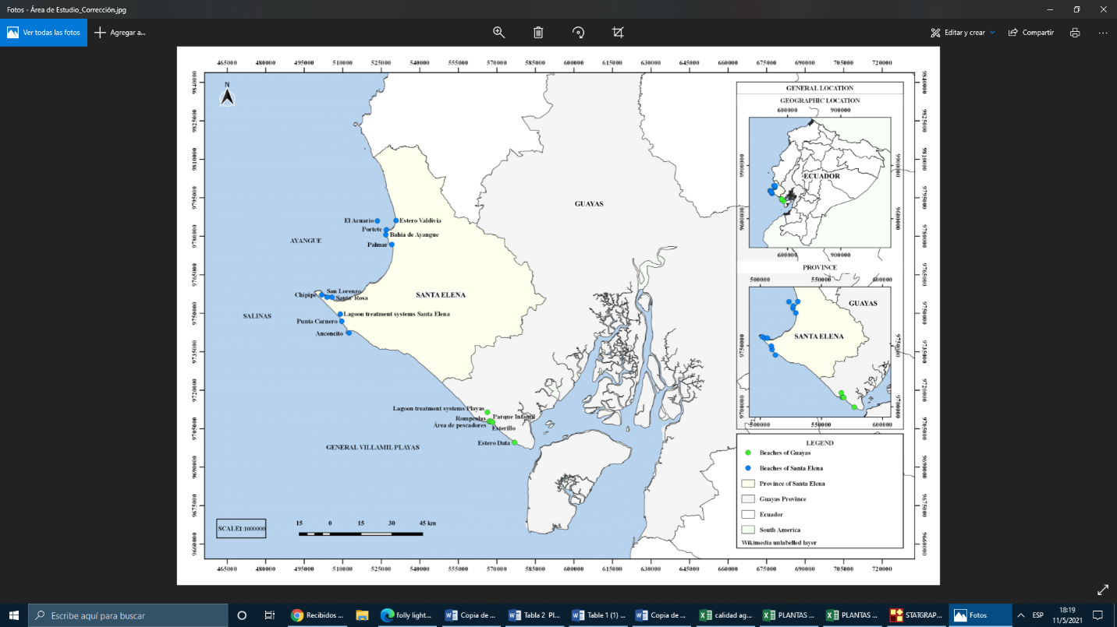

**Figure 1**. Samplings locations of the study area

**Environmental Measurements**

The environmental parameters (physical and chemical) data were collected. Temperature (Temp), pH, salinity (Sal), total solids suspended (TSS), dissolved oxygen (DO) were measured *in situ* using YSI HQ30d multiparameter probes. Chemical Oxygen Demand (COD), Biological Oxygen Demand (BOD), Oils and fats (OF), surfactants, chlorine, and ammonium. The microbiological measurements such as: *Fecal coliforms* (FC), *Escherichia coli* (EC) and SARS-CoV-2 were measured in the laboratories using different methods. A different treatment was performed for each variable using spectrophotometer and qRT-PCR.

**SARS-CoV-2 Analysis**

**Viral particle concentration and RNA isolation**

The analysis of SAR-CoV-2 was carried out at two laboratories of the Ecuadorian NHI: 1) the Multidisciplinary Center for Research and 2) the Reference National Center for Exanthematic and Arthropod Borne Viruses. Water samples were processed into a biosafety cabinet Class II, Type A 2. One of the key factors for virus detection in water is the use of methods that allow the concentration of viral particles in enough amounts to be detected by the diagnostic test of interest. We evaluated two different methods: 1) skimmed milk organic flocculation (SMF), which is based on the capacity of the proteins to form flocs where the viruses present in the samples usually adhere (Calgua et al., 2008) and 2) concentration of organic particles with an aluminum chloride solution (AlCl₃), based on viral adsorption–precipitation (Randazzo et al. 2019). A brief modification was introduced for the SMF methods, 1000 mL was used as initial sample volume instead of 10 L, and ~ 100 mL of water containing flocks were processed for the centrifugation steps. To test whether the concentration methods were effective, we spiked a water sample with Dengue Virus serotype 2, cultured in C6/ cells. For SMF we started from a 1:10 dilution and then performed serial dilutions up to 1:1000, for AlCl₃ we used a sole 1:100 dilution AlCl₃. The water discarded in the different stages of the viral concentration procedure was treated with chlorine prior to its elimination through the laboratory's piping. We also evaluated water samples without pretreatment for concentration of viral particles, 1000 mL of sample was used for this purpose. RNA was extracted using the commercial QIAamp Viral RNA Mini Kit Cat No./ID: 1020953 (Qiagen 19300 Germantown Road, Germantown, MD, USA) following the manufacturer's instructions.

**qRT-PCR analysis**

Analysis of Dengue Virus and SARS-CoV-2 was conducted using a one-step PCR procedure. For DENV we use the commercial Simplexa™ Dengue Kit, Ref MOL3100 (FOCUS Diagnostics) which includes primers for detection of all four DENV serotypes, we did a monoplex reaction for detecting DENV 2, reactions were run on a brand’s proprietary thermocycler M3. Detection of SARS-CoV-2 was done using the SuperScript III Platinum One-Step qRT-PCR kit, Ref 11732-088 (invitrogen) and primers designed by the CDC, which detect two genes of the viral nucleocapsid (N1 and N2). The primers and positive control for SARS-CoV-2 and human ribonuclease P (RNase P) were purchased from Integrated DNA Technologies, Inc. (1710 Commercial Park Coralville, Iowa 52241 USA). In general, we followed the manufacturer procedures as described at<https://www.fda.gov/media/134922/download>. Each One-Step qRT-PCR reaction contained ultrapure water 0.5 µl, buffer mix 12.5 µl, RT enzyme 0.5 µl and primers 1.5 µl. Reactions were run on a BIO-RAD CFX96 Real-Time PCR System, with the following thermocycling: one cycle of 50°C for 30 seconds, one cycle 95°C for 2 minutes and 45 cycles of 95°C for 15 seconds and 60°C for 1 minute. As for the CDC protocol, RT-PCR amplification with CT <40 for both genes N1 and N2 was considered positive, amplification of only one gene was considered inconclusive and no amplification was considered negative. Amplification of RNase P gene is not expected from environmental samples. RNA samples leading to positive results were sent for confirmation to the National Reference Center for Influenza and other Respiratory Viruses of the Ecuadorian NHI, laboratory fully accredited and certified by the World Health Organization for diagnosis of SARS-CoV-2. This laboratory uses the protocol of the University of Charité which detects a gene of the viral envelope (E).

**Statistical analysis**

The data exploration was done using R software version 4.0.2. Statistical tests were carried out to analyze whether the data presented a normal distribution, a Kolmogorov-Smirnov test was conducted and the Levene test for homoscedasticity (Zar, 1996). Subsequently, to compare pH, temperature and salinity between sites, a one-way ANOVA test (p <0.05) with a Tukey a posteriori test was applied. Then, to compare oils and fats, NH4, OD, COD, BOD, *fecal coliform* and *E. coli* a non-parametric Kruskal-Wallis test was applied (p <0.05). In order to determine if there was a correlation between the variables under study, a Spearman analysis was performed. To analyze the interrelationships between the microbiological, physical and chemical variables, an analysis of the principal components was conducted (Clarke & Gorley, 2006). Finally, the distribution of fecal coliforms in the coastal areas and WWTPs and pollutants critical points are depicted in the Ecuadorian map using QGIS programm version 3.4.3.

**Results**

**Environmental data**

Mean values (± SD) of all measured physical and chemical variables are summarized in Table 1. There were significant (p <0.05) differences between sampling sites for temperature, salinity and oils and fats. The pH ranged from 6.5 to 9.5. The temperature ranged from 23.6 ° C to 34.4 ° C, mainly due to differences between the time of survey (early in the morning or past midday). The salinity ranged from 0.5 PSU at Area de Pescadores ( Playas ) to 60.2 PSU in the middle estuary from Estero Valdivia (Ayangue) during high tide in the rainy season. The highest salinity values were in the rainy season. Oxygen levels were lower in the Area de Pescadores, Estero Valdivia and fishing port in Anconcito (<3) values ​​were found below the recommended concentration for the preservation of the flora and fauna (5 mg / L). The higher TSS was observed at Ayangue in the Estero Valdivia (698 mg/L) in an area close to pig farm, Fisherman area (114 mg/L) and Esterillo 2 (86 mg/L) located near restaurants in Playas mainly in the rainy season.

Generally, the highest concentrations of oils and fats were found in fishing boats and landing ports (Anconcito, Portete Grande and Estero Data 1) and water channels where discharge domestic and industrial runoff at Playas´s population in the intertidal zone called Esterillo. In addition, ammonium ranged from 0.12-8 mg/L with highest levels at intertidal zones where domestic wastewater is discharged (Area de Pescadores) and estuarine zones as: Esterillo and Estero Valdivia. The concentrations of residual free chlorine and surfactants were less than the detection limit <10 mg/L and <0.05 mg/L respectively.

**Table 1. Physico-chemical parameters in the seawater of the beaches under study.Equal letters indicate that there are no significant differences between the station means, according to one-way ANOVA and Tukey's a posteriori test. * Indicates that there are significant differences according to Kruskal-Wallis (p <0.05). Equal letters indicate that there are no significant differences between the station means, according to one-way ANOVA (F) and Tukey's a posteriori test. * Indicates that there are significant differences according to Kruskal-Wallis (H) (P>0.05), MPL: maximum permissible level according to AM 097A. ND: not detectable**



COD ranged from 27 mg/L to 820 mg/L. The highest values were observed during the rainy season at the outer and middle branches of Estero Valdivia. These levels exceeded the permissible COD limits for the preservation of flora and fauna according environmental laws in Ecuador (400 mg/L). Other sites with high levels of COD were observed at the estuarine zones from Playas and Ayangue such as Estero Data 1 (384 mg/L), Estero Data 3 (302 mg/L), Palmar 3(260 mg/L) (200 mg / L) and the beach Punta Carnero (210 mg/L ) (Figure 2C). BOD ranged from 2 to 200 mg/L and higher levels were observed only at Estero Valdivia in the middle (150 mg/L) and outer estuary (200 mg/L) during the rainy season (Figure 2B).

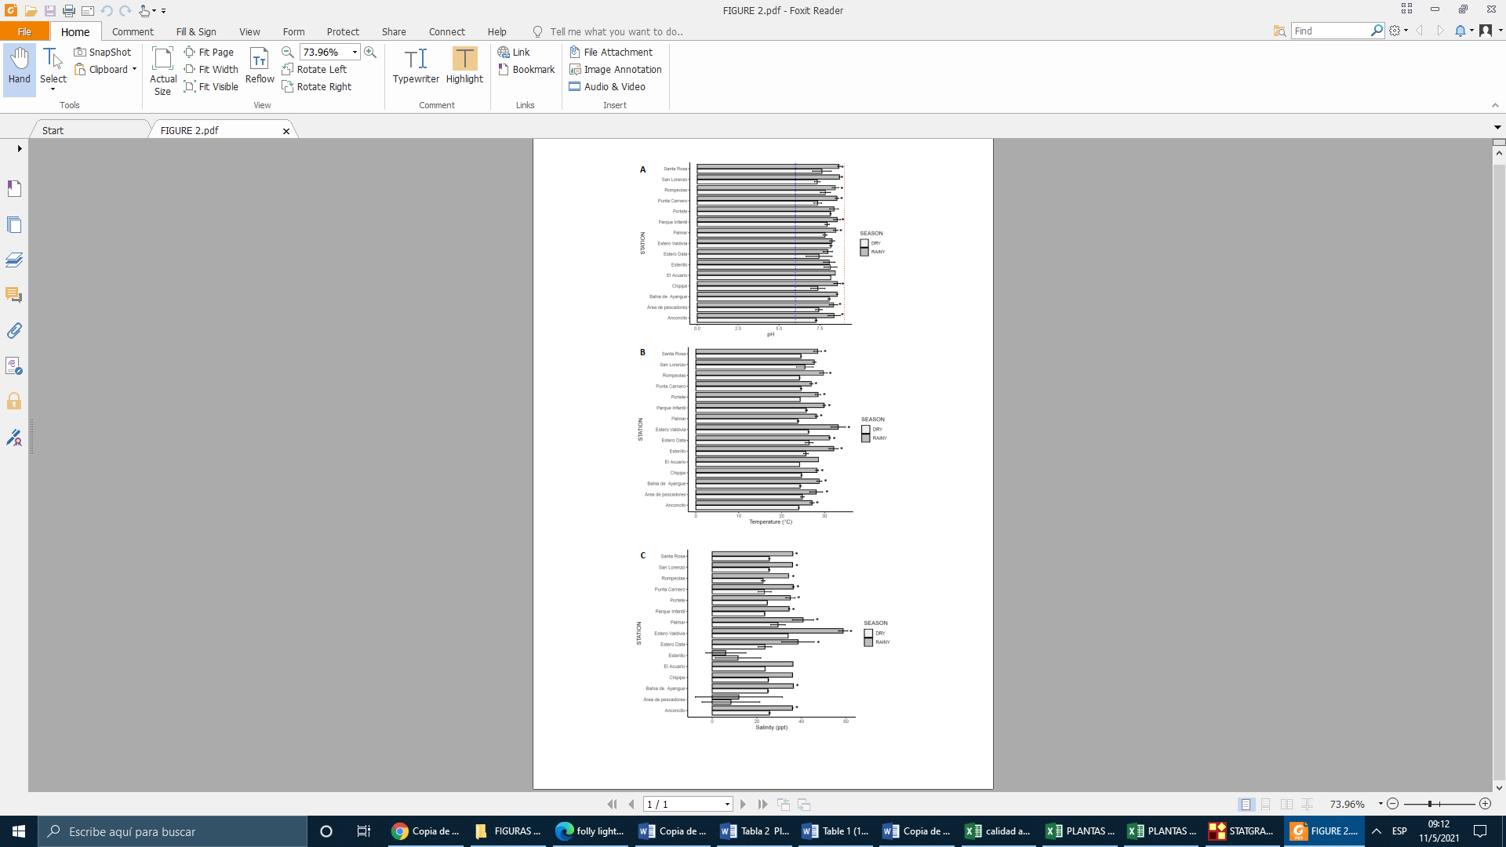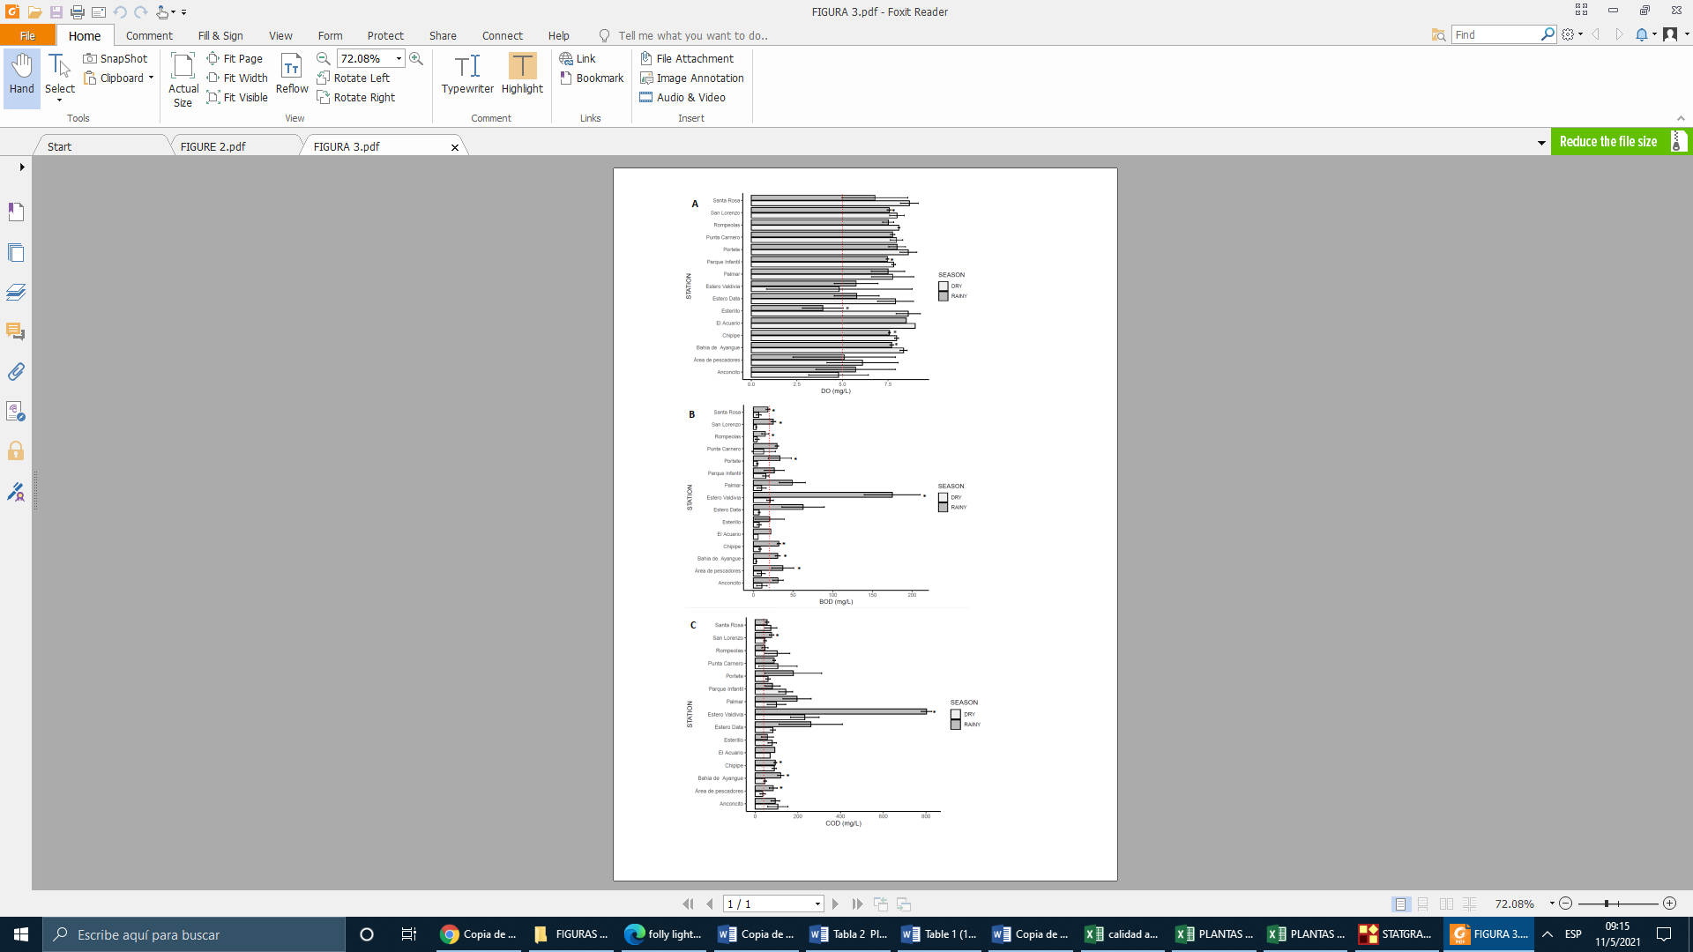

**Figure 2. pH, Temperature and salinity values are showed in left and dissolved oxygen (DO), biological oxygen demand (BOD) and chemical oxygen demand (COD) in the seawater of the beaches under study.**

**Microbiological assessment**

Levels of fecal coliforms and *E. coli* were consistently more concentrated in seawater and wastewater discharged in estuarine zones compared to shoreline sand. FC levels and *E. coli* were the highest at fish landing and management facility located at Anconcito Artesanal Fishing Port, channel of domestic wastewater (Esterillo 1 and 2). These areas are closed to restaurants and public restrooms, ~~on the coastline near to~~ urbanizations near the coastline (Portete Grande Casa del Sol), and an estuarine area influenced by urban settlement (Palmar 1) (Figure 3). No SARS-Cov-2 was detected on these beaches.

Fecal coliform levels were >200 to 63,000 MPN/100 mL in most locations. The highest values ​​were detected in Anconcito (63,000 MPN/100 mL), Esterillo (9,200 MPN/100 mL), Portete (7,000 MPN/100 mL) and Palmar (4,000 MPN/100 mL). Same patterns were registered for *E. coli* (Figure 3). Only ten from forty two sites can be used for recreational purposes as they are suitable for primary contact according to environmental laws in Ecuador through ministerial agreement 097A (Acuerdo Ministerial 097A, 2015) where, it is recommended that for recreational purposes, waters should not exceed 200 MNP / 100 mL. These sites were Rompeolas, Parque Infantil 2 and Estero Data 1 in Playas; Punta Carnero 1 and 2, Chipipe 1 and 2; San Lorenzo 1, 2, 3 and Estero Valdivia in Santa Elena. There was a statistically significant difference between sites ~~at 95% confidence~~ for fecal coliforms (p= 0.03) and *Escherichia coli* (p=0.03). The levels of FC and *E. coli* were higher during rainy season when beaches were opened for tourism ( p<0.05:p 0.01) in comparison with the dry season ~~(closed beaches)~~. The FC were higher in Santa Elena compared to Playas (p<0.05: 0.01) during both sampling events. However, more sites showed water polluted with FC and *E coli* in the area from Ayangue, area preferred by tourists for its calm waters especially in Ayangue Bay and surroundings.

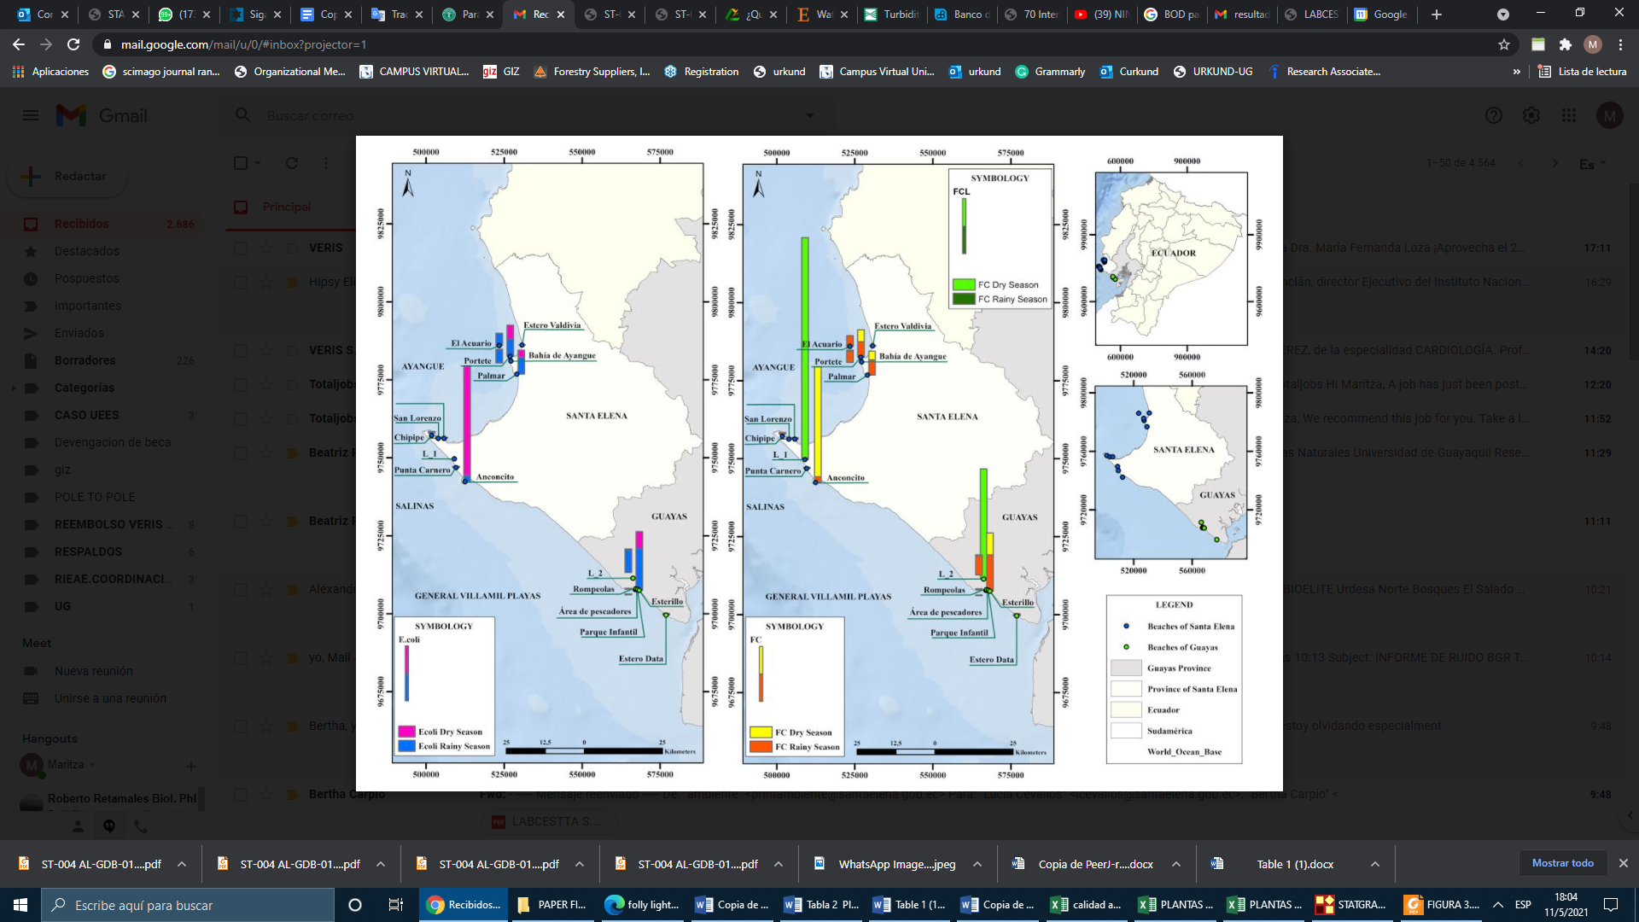wo

**Figure 3. Spatial distribution of Fecal coliforms and *E. coli* in the seawater and wastewater treatment systems during 2020-2021.**

**Microbiological pollution in Wastewater in Treatment Plants**

The average concentration of FC in wastewater treatment plants was 1.28 x 106 ± 3.21 x 106 SD. The highest levels of FC were observed during the 2020 dry season with values of 9.2 x 106 NMP/100 mL and 1.2 x 105 NMP/100 mL at the influents of Santa Elena and Playas WWTPs, respectively. These results may reflect the lockdown imposed by the government of

Ecuador during the COVID-19 pandemic. Moreover, the microbiological indicators of water quality from WWTP depicted in table 2 is two-fold the values above the permissible limit of 2000 MPN/100 mL ~~for discharge from wastewaters to seawater in Ecuador~~. In contrast to the situation in the beaches, the SARS-CoV-2 virus was found in wastewater, possibly associated with high concentrations of fecal coliforms. The null hypothesis was verified, which indicated that the malfunction of the treatment plants results in the contamination of the marine water bodies.

**SARS-CoV-2 Analysis**

Two viral concentration methods evaluated, SMF and AlCl3, lead to detection of DENV-2 in all dilution tested suggesting these procedures are effective to adhere enveloped viruses such as coronaviruses. Given this result, and due to less processing time, the remaining samples were processed preferentially using the AlCl3 procedure. Analysis of SARS-CoV-2 was conducted on samples from two WWTPs (one in Playas-Guayas Province and one from Santa Elena-Santa Elena Province) and five coastal waters exceeding permissible limits of FC. The results of the RT-PCR is shown on table 3. Genes N1 and N2 of SARS-CoV-2 were detected in influent and effluent samples from both WWTPs. These findings were confirmed by the National Reference Centre for Influenza and other Respiratory Viruses through amplification of the viral gene E. In 4 coastal water locations, only the N1 gene was amplified. In accordance with the CDC guidelines the result for these samples was considered inconclusive. Of the samples with inconclusive results two samples were also processed using the SMF method. RT-PCR confirmed the results as inconclusive. As expected, the RNase P gene control did not yield any amplification.

To detect a possible origin of the contamination, water samples from located in Playas and Santa Elena were analyzed. As shown in Table 3, these water treatment plants did not show significant differences between their parameters pH, surfactants, Oils & fats, COD, BOD and fecal coliforms (Student's T distribution P> 0.05). The surfactants parameter (2.28 ± 1.53 mg/L) exceeded two-fold the maximum permissible limit in Santa Elena WWTP (Table 2). Moreover, COD and BOD slightly exceeded the permissible limit for discharges into continental marine water bodies in the city of Playas.

**Table 2. Microbiological and physicochemical parameters of water treatment plants located in Playas Villamil and Santa Elena**

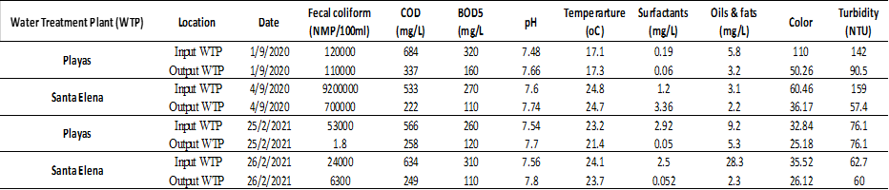

**Table 3. Microbiological and physicochemical parameters of water treatment plants located in the provinces of Santa Elena and Guayas. LMP :limit for discharge in seawater. t Student. p-value.**

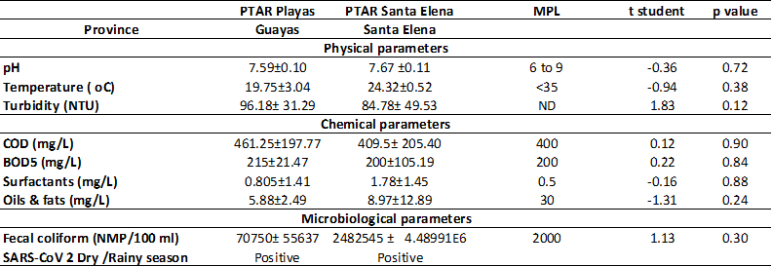

**Correlation between physico-chemical and microbiological parameters**

An analysis of principal components was conducted. We observed that four components explained 80% of the correlation between variables (Figure 4). The first dimension, Dim1, depicts a correlation between BOD and COD concentration; and CP2 shows a relationship between the concentration of *E. coli* and fecal coliforms. The analysis showed a strong correlation between *E. coli* and Fecal coliforms and BOD and COD (Figure 4). The Spearman correlation analysis shows (Table 3) a strong association between the concentration of *E. coli* and fecal coliforms (Rho = 0.848) and between BOD and COD (Rho = 0.713) and a moderate and inversely proportional relation between DO and BOD (Rho = -0.401) and between OD and oil and fats (Rho = -0.410). ~~Similarly, an analysis of principal components was carried out, where it was possible to see that four of them explained 80% of the correlation between variables (Figure 4). The first component, Dim 1, shows the correlation between BOD and COD concentration; and CP2 showed a relation between the concentration of~~ *~~E. coli~~* ~~and fecal coliforms.~~

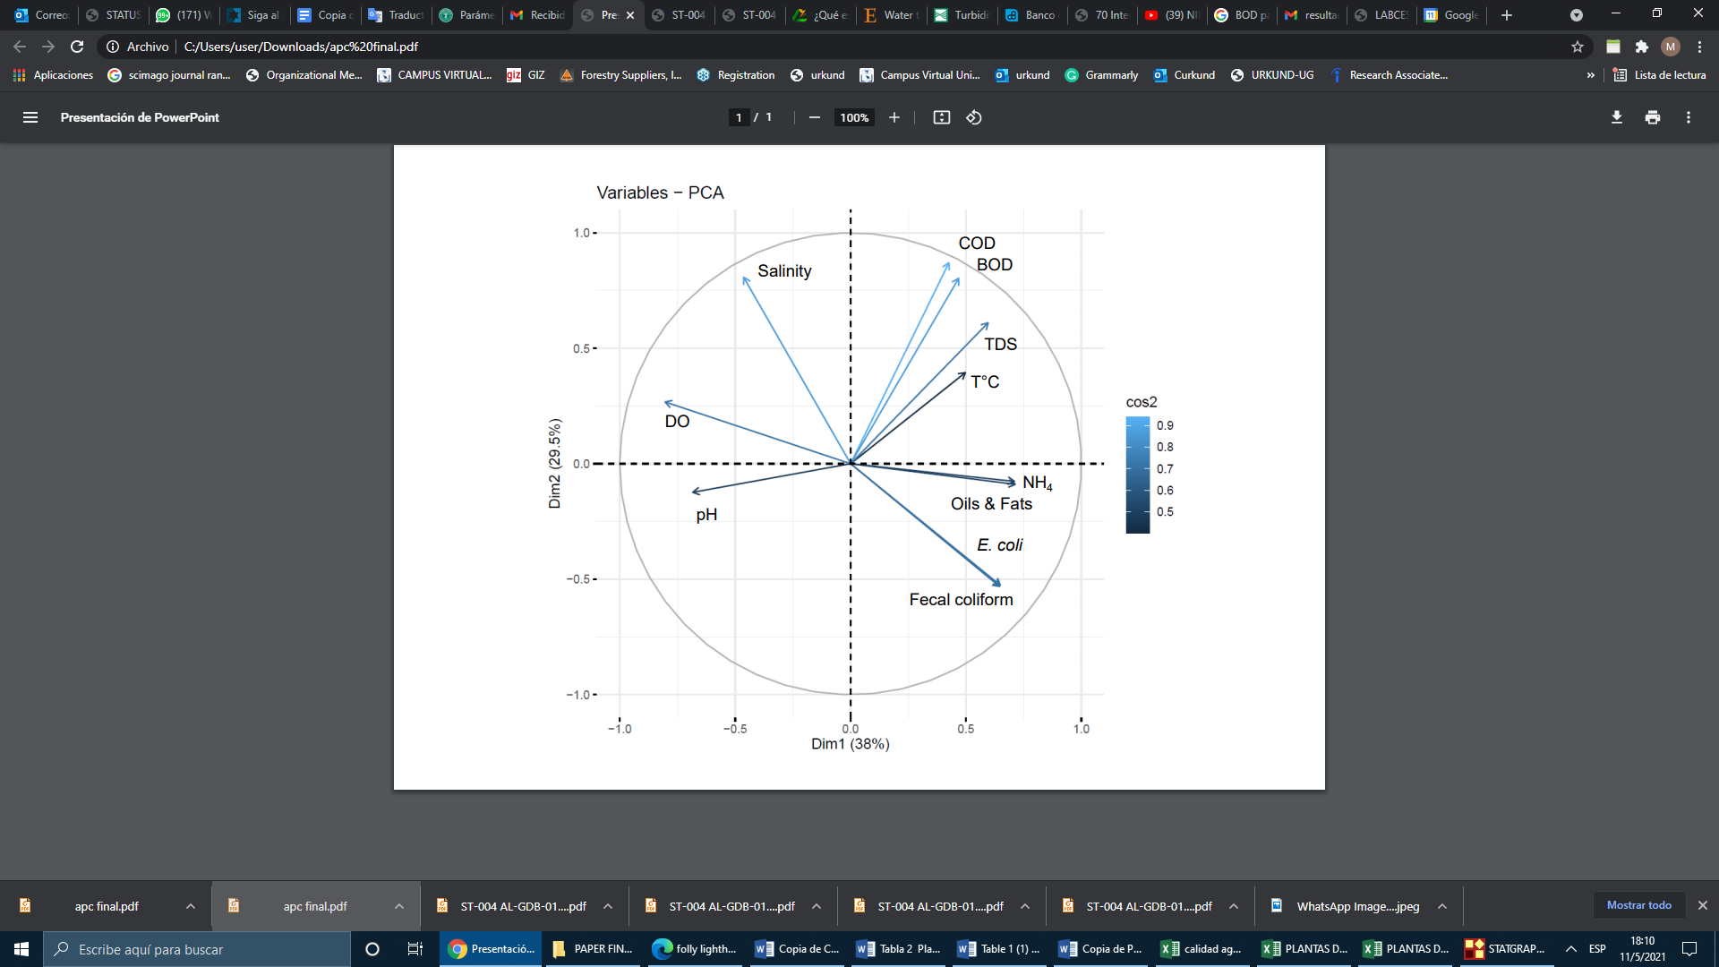

**Figure 4.** Analysis of principal components among the variables under study on the beaches of Guayas and Santa Elena.

**Discussion**

Overall, water quality parameters of samples analyzed show a negative impact on the beaches associated with anthropogenic activities, the presence of fecal coliforms and *Escherichia coli* with values that exceed the maximum permissible levels in Ecuadorian environmental legislation in areas influenced by fishing ports, wastewater, and urbanizations. Within this context, 9 out of fifteen beaches analyzed were not suitable for primary contact. With the exception of Anconcito and Portete, all other beaches were suitable for secondary contact or recreational activities (i.e. water sports and fishing). Besides discharges of domestic wastewater, other factors that contribute to water pollution include runoff, contaminated water from rain or subsoil, river mouths with contaminated water and defecation of bathers directly into seawater (Badilla-Aguilar et al., 2019). The present studywas conducted during the COVID-19 pandemic when the use of beaches was prohibited. Thus, we can infer that microbiological contamination should be greater during holidays where there is a greater influx of tourists.

On the other hand, the fact eight from fifteen beaches studied are contaminated with the *E. coli* bacteria associated with gastrointestinal disease, shows the risk of suffering some disease in the users of these beaches. Of the 8 beaches, those with the highest contamination were Anconcito and Esterillo. The explanation for this contamination in the two most polluted beaches is due to the fact that the treated water is discharged into the oxidation ponds that showed high concentrations of fecal coliforms and is also reflected in the high chemical oxygen demand.

The levels of FC were very high in the oxidation lagoons, which shows that this system is inefficient for the elimination of pathogenic microorganisms and coincides with the high values ​​of coliforms found on the beaches near the water discharge areas of the oxidation ponds. While the levels of coliforms were very high in the oxidation ponds, they were found in lower significant values on the beaches where these waters were eventually discharged, and the presence of the SARS-CoV-2 virus was not detectable. Factors such as dilution effect, salinity, incidence of ultraviolet rays and temperature of the sea may have played significant roles in the detection of SARS-CoV-2 . In this context, it has been described that the survival of microorganisms in the environment depends on many factors such as temperature, incidence of sunlight and the presence of native microorganisms (Pinon & Vialette, 2019).

Another impact of the discharge of inefficiently treated wastewater to the beaches was the low levels (less than 5 mg/L) of oxygen measured. Sewer overflows or poorly treated effluents discharged from these reservoirs often contribute to the level of oxygen demand of the receiving waters. ~~, due to the greater depletion of dissolved oxygen in the surface waters that receive water..~~ Similar to the present study, in other reports DO levels in effluents from various wastewater treatment facilities in South Africa were typically lower than the required standard of 8 to 10 mg / L and the DO level per below 5 mg/L negatively affects the aquatic ecosystem (Edokpayi et al., 2017). The effect of poorly treated wastewater on surface waters is largely determined by the oxygen balance of the aquatic ecosystem, and its presence is essential to maintain biological life within the system (Edokpayi et al., 2017). Therefore, there are negative impacts of the lagoon systems in Playas and Santa Elena, impacting the local flora and fauna of these sites, which coincides with previous studies carried out in Playas (Espinoza, 2016) and Santa Elena ( Córdova, 2013).

In the present research, high levels of COD and BOD were observed in the oxidation lagoons that resulted in impairment of water quality of the surrounding beaches. BOD and COD usually give an estimate of organic contamination in water and wastewater. They are relevant wastewater quality parameters, as they are used to measure the efficiency of most facilities. To support aquatic life, surface water is expected to have low BOD/COD values ​​. The high BOD and COD levels can cause damage to aquatic life, especially fish (Edokpayi et al., 2017). Furthermore, we observed an inverse relationship between COD levels and DO concentrations. When there are biodegradable organic substances in the water, the bacteria consume the DO, decreasing DO levels ~~falls below the threshold,~~ with a negative impact on maintenance of aquatic life. Such decline affects growth and reproduction of fish and other forms of aquatic life (Edokpayi et al., 2017).

Regarding the oxidation lagoons, SARS-Cov 2 was found in wastewater from the Playas and Santa Elena. A further risk assessment was conducted, and *in vitro* tests using cell cultures determined that the virus in wastewater is not able of infecting Caco-2 cells (data not shown). Nevertheless, our results indicate that there is contamination by organic matter in the water of the beaches studied.

The low levels of salinity generated by the wastewater discharged into the intertidal zone of the Playas area are probably related to clandestine connections that throughout the year affect biological communities. Especially benthic communities that inhabit the estuarine area of the Esterillo and sandy beaches in the area where fishermen land. High levels of salinity registered in the Estero Valdivia may be associated to low water exchange flow combined with evaporation/precipitation rates. ~~, being this more evident during low tide~~.

**Conclusions**

Fecal coliforms and *Escherichia coli* were more concentrated in areas with fish landing, management facility located at Artesanal Fishing Port, urban settlements in the coastal margin and estuaries that receive wastewater from domestic wastewater. It is also concerning to record levels of FC in locations visited massively by tourists. Their presence may indicate other enteric pathogens such as Hepatitis A, *Citrobacter*, *Shigella* and *Salmonella* that can cause liver damage, gastrointestinal and dermal diseases. This study represents a baseline into monitoring water quality related to enteric bacteria and viruses that can be transmitted through food and water intake to the population.

Additionally, the fishing facilities are sites for the landing, marketing, sale and distribution of fish where stay large number of fishermen and they are exposed to poor hygiene conditions, wastewater with bloody waters derived from the evisceration of fishes and waters contaminated with fecal coliforms. Therefore, they are exposed to possible contacts with SARS-CoV-2 and must be a priority group to be vaccinated to prevent COVID-19.

Approximately 81% of the beaches here studied are not suitable for recreational purposes as they exceeded the maximum permissible limit of water quality. The SARS-CoV-2 virus was detectable only in two coastal areas as bay and outlet estuary only in opened public beaches season and high season of tourism. Therefore, a monthly control and monitoring of wastewater and SARS-CoV-2 is suggested to avoid possible contagion with this virus to local residents and tourists. Besides this studies help to obtain of safe beaches certifications for recreational activities in marine and estuarine waters in long term

Regarding the wastewater treatment plants, the levels of fecal and total coliforms were very high in the oxidation ponds and the presence of the SARS-CoV-2 virus was detected, indicating that the wastewater treatment process is not very efficient and must be complemented with additional treatments such as ultraviolet light, ozone or chlorine dioxide, in order to minimize pollution on the beaches where the treated waters are discharged and these are suitable for bathers.

Similarly, the inefficient treatment of sewage generated high levels of COD and BOD on the beaches, which resulted in the reduction of dissolved oxygen to values that are dangerous for the life of the fish on the Anconcito beach and in the Estero Valdivia. While the risk to get infected with COVID-19 remains low, we demonstrated that SARS-CoV-2 is present in seawaters and estuarine.

Finally, the water quality parameters analyzed show pollution problems generating a negative impact on the environment and economic development of the study areas. Local governments and the national government should consider improving or changing the management of domestic wastewater in the coastal marine zone of Playas and Santa Elena. For instance, we suggest to migrate from primary systems to more efficient ones that are consistent with the current needs of the populations. Authorities need to consider local population growth and fluctuating populations that arrive to Playas and Santa Elena counties. Within this context, financial support could be requested from international organizations such as the Inter-American Development Bank (BID in Spanish), the Development Bank of Latin America (CAF in Spanish) or other multilateral organizations considering the needs of urban and hospitality industry growth in coastal lines. Finally, economic reactivation post COVID-19 pandemic will rely on the governmental vaccination program and agreements between Ecuador and the foreign counterparts to expedite the acquisition of vaccines for the Ecuadorian population. Once a program is fully implemented and population achieves herd immunity (as it has occurred in developed countries), restrictions can be lifted and activities such as tourism and industries such as aquaculture, mariculture and agriculture will help to bounce back Ecuadorian economy.

**Acknowledgements**

The authors thank Bertha Carpio from Prefectura de Santa Elena for help with the fundraising for the sampling development in Santa Elena in 2020. Supplemental support was provided by the Secretary of Higher Education Science, Technology and Innovation from Ecuador (SENESCYT) and La Deutsche Gesellschaft für Internationale Zusammenarbeit (GIZ) DC program Sustainable Intermediate Cities in Ecuador. Component 3 "Strengthening of the Academy and Applied Research Institutes" grant No. 14.2160.1-001.00. We thank Ely Soares and Philipo Franco from the City of Playas (GAD Playas) for logistics and transportation during the COVID-19 pandemic. We acknowledge the Ecuadorian Ministry of the Environment and Water (MAAE in Spanish) for the authorization to carry out research in Protected Areas: Área Nacional de Recreación Playas Villamil, Reserva de Producción de Fauna Marino Costera Puntilla de Santa Elena and Reserva Marina El Pelado. We thank Fanny Condo and María Belén Delgado from the Ecuadorian Ministry of Tourism (MINTUR in Spanish) for promoting and logistically supporting the realization of this research. We also thank Doménica de Mora and Maritza Olmedo from the National Reference Centre for Influenza and other Respiratory Viruses confirming SARS-CoV-2 results. A special thanks to Carlos Muñoz, Dean of the Faculty of Chemical Engineering of the University of Guayaquil, who unconditionally supported all the researchers of the Ambiente Sociedad and Empresa (ASE) group for the development of this research and all the members of the Inter-Institutional Network for the Study of Aquatic Ecosystems of Ecuador (RIEAE) who supported this research.

**References**

Cantalupo, P.G.,Calgua, B.,Zhao,G.,(2011). Raw Sewage Harbors Diverse Viral Populations. Vol.2:pp.1-11

.

Clark ,K. & Gorley ,R.N. (2006). Primer : User Manual /Tutorial. UK. Plymouth.

Clark,K.R.,Gorley,R.N.,Somerfield,. P.J., & Warwick,R.M. (2014). Change in marine communities: An approach to statistical analysis and interpretation,3ed ed. Plymouth: PRIMER-E Ltd.

C.G. Daughton. (2020). Wastewater surveillance for population-wide COVID-19: The present and future, SCi.Total Environ.736,139631.

Córdova, D. (2013). Evaluación técnica y ambiental de las lagunas de oxidación del canton Salinas ubicadas en la vía Punta Carnero. Tesis para la obtención del título de ingeniero Civil de la Universidad Católica Santiago de Guayaquil. Guayaquil. 152p.

Espinoza, F. (2016). Estudio de Impacto Ambiental de las lagunas de oxidación de alcantarillado sanitario de Hidroplayas EP. 270p.

Keller M, Zengler K. Tapping into microbial diversity. Nat Rev Microbiol [Internet]. 2004/03/26. 2004;2(2):141–50. Available from: <http://www.ncbi.nlm.nih.gov/pubmed/15040261>

Li H, Durbin R. Fast and accurate short read alignment with Burrows-Wheeler transform. Bioinformatics. (2009); Mapleson D, Drou N, Swarbreck D. RAMPART: A workflow management system for de novo genome assembly. In: Bioinformatics. 2015.

Martin M. 2011. Cutadapt removes adapter sequences from high-throughput sequencing reads. EMBnet.journal.

Masaaki Kitajima, Warish Ahmed, Kyle Bibby, Annalaura Carducci, Charles P. Gerba, Kerry A. Hamilton, Eiji Haramoto, Joan B. Rose. (2020). SARS-CoV-2 in wastewater: State of the knowledge and research needs, Science of The Total Environment, Volume 739.139076.

MSP, 2020. Boletín provincial Guayas Extracción 03/05/20208:00a.m <https://www.salud.gob.ec/coronavirus-covid-19/>

Ministerio de Salud, 2020.

<https://www.salud.gob.ec/wp-content/uploads/2020/04/Guayas_Guayaquil.pdf>

Nghiem, L. D., Morgan, B., Donner, E., & Short, M. D. (2020). The COVID-19 pandemic: considerations for the waste and wastewater services sector. Case Studies in Chemical and Environmental Engineering, In Press. https://doi.org/10.1016/j.cscee.2020.100006

Organización Panamericana de la Salud. Directrices de Laboratorio para la detección y diagnóstico de la Infección con el Nuevo Coronavirus 2019 (2019-nCoV). PAHO

R. J. Duintjer Tebbens, M. Zimmermann, M. A. Pallansch, K. M. Thompson, Insights from a Systematic Search for Information on Designs, Costs, and Effectiveness of Poliovirus Environmental Surveillance Systems. Food Environ Virol. 9, 361–382 (2017).

S. Blomqvist, L. E. Bassioni, E. M. E. M. Nasr, A. Paananen, S. Kaijalainen, H. Asghar, E. de Gourville, M. Roivainen, Detection of Imported Wild Polioviruses and of Vaccine-Derived Polioviruses by Environmental Surveillance in Egypt. Applied and Environmental Microbiology. 78, 5406 (2012).

WHO, 2020. Declaración sobre la segunda reunión del Comité de Emergencias del Reglamento Sanitario ‎Internacional (2005) acerca del brote del nuevo coronavirus (2019-nCoV). https://www.who.int/es/news-room/detail/30-01-2020-statement-on-the-second-meeting-of-the-international-health-regulations-(2005)-emergency-committee-regarding-the-outbreak-of-novel-coronavirus-(2019-ncov)

WHO, 2020. Coronavirus disease (COVID-19) Situation Report – 104

https://www.who.int/docs/default-source/coronaviruse/situation-reports/20200503-covid-19-sitrep-104.pdf?sfvrsn=53328f46_2

X. W. Wang, J. Li, T. Guo, B. Zhen, Q. Kong, B. Yi, Z. Li, N. Song, M. Jin, W. Xiao, X. Zhu, C. Gu, J. Yin, W. Wei, W. Yao, C. Liu, J. Li, G. Ou, M. Wang, T. Fang, G. Wang, Y. Qiu, H. Wu, F. Chao, J. Li, Concentration and detection of SARS coronavirus in sewage from Xiao Tang Shan Hospital and the 309th Hospital of the Chinese People’s Liberation Army. Water Sci. Technol. 52, 213–221 (2005).

Zar, J.H. (1996) Biostatistical Analysis. 3rd Edition, Prentice Hall, Inc., Upper Saddle River.